Turning off sleeping function operating instruction

1. Upgrade purpose: to disable the automatic hibernation function of the ASM1153E main control chip hard disk box
2. Install upgrading tool：
3. unzip the following file to “ASM 1135E Tools for Turning off sleep Mode”file on pc destop。



（ picture 1 ）

②、“ASM 1135E Tools for Turning off sleep Mode”file folder as follows：



（ picture 2 ）

③、.Before installing the upgrade tool, please close the anti-virus software before installing。

④、Open“Upgrade tools”file folder，double click “”file to open upgrading tool（picture 3）：

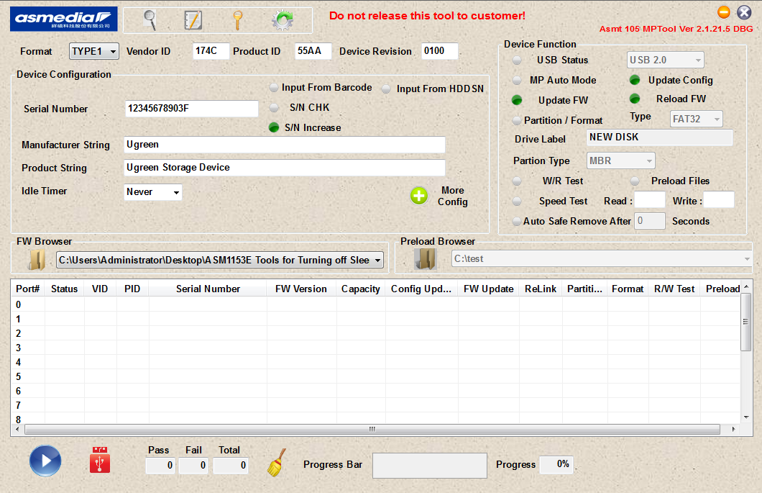

（ picture 3 ）

二、Turn off automatical sleeping function：

①、Set turning off sleeping time as the picture 4 shows; the detailed operating method : click drop-down menu， next choose “10Min”, then choose“Never”

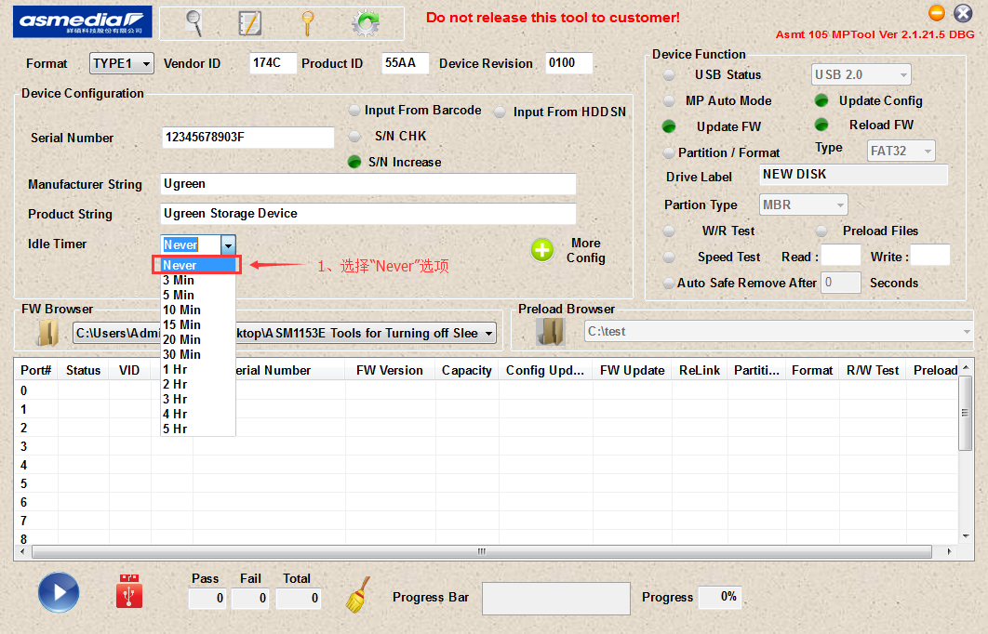

（ picture 4 ）

②、Following the picture （5） to open program ： please make sure the program is stored in“C:\Users\Administrator\Desktop\ASM1153E Tools for Turning off Sleep Mode”， or the upgrading maybe fail .

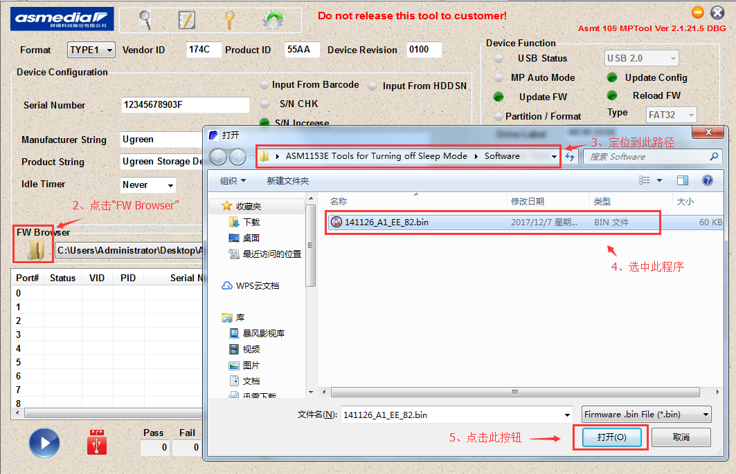

（ picture 5）

③、Connect case to pc ，then upgrade the program following picture（6）。

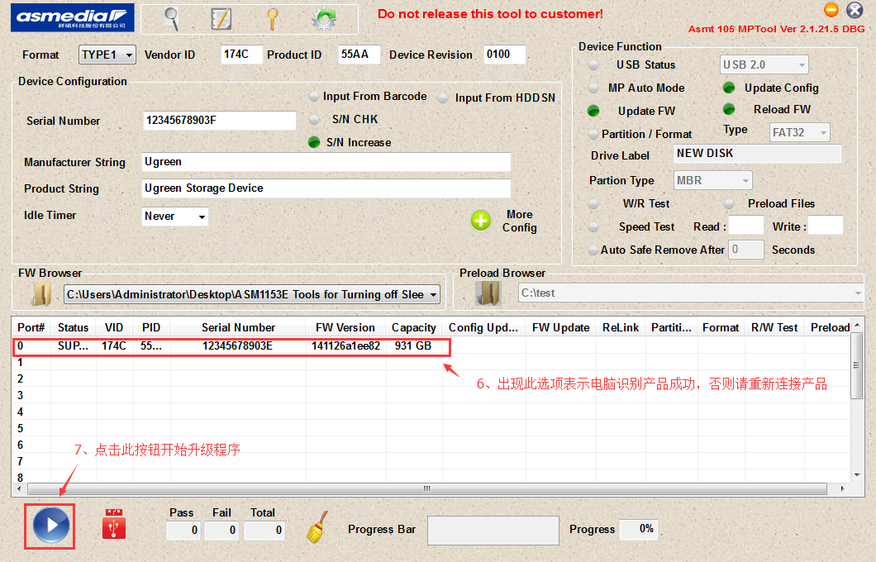

（ picture 6 ）

④、successful upgrade is as picture（7）shows; if there shows “Fail”, it means upgrade failure， then please operate once again following the operating instruction above:

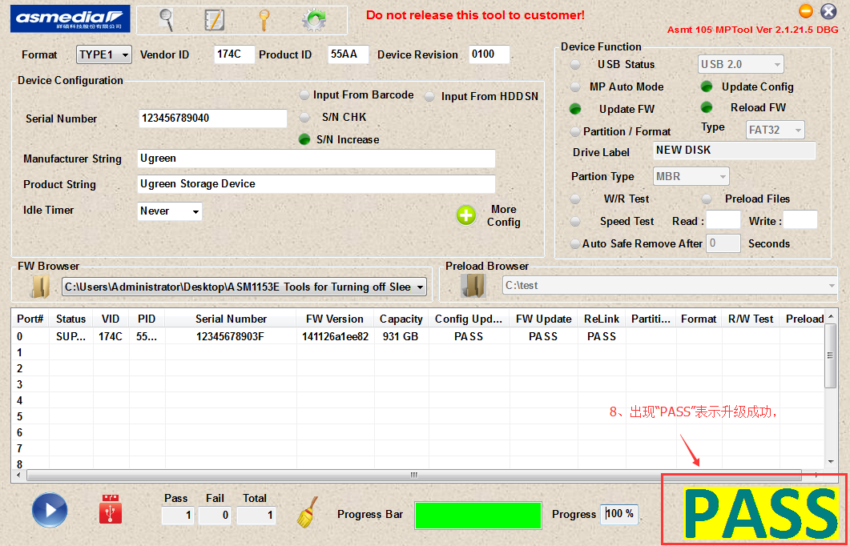

（picture 7）

1. note：
2. if pc fails to detect hdd case , please unplug and plug hdd case with pc , or try pc other usb-A ports;
3. This upgrade tool must be used on WINDOWS(WINXP/WIN7/WIN8/WIN10) pc ;
4. After successfully upgrading, please detect this tool from pc .

曹昌盛 20181113